The Excellence through Quality Improvement Project (E-QIP)
Expression of Interest in Quality Improvement & Data Coaching Support
Due: October 11, 2019
PART 1: PROFILE
ORGANIZATION NAME: ________________________________________________
NUMBER OF FTEs: ____________
CITY OR COUNTY: ________________________________________________
NAME OF QI CONTACT: ________________________________________________
EMAIL: ________________________________________________
TELEPHONE: ________________________________________________

AFFILIATION:
AMHO MEMBER ___ CMHA BRANCH___ BOTH___

ARE YOU APPLYING FOR COACHING AS A:
SINGLE AGENCY ____ GROUP OF PROVIDERS/ NETWORK _____

ARE YOU A MEMBER OF THE E-QIP COLLABORATIVE ONLINE COMMUNITY OF PRACTICE (QUORUM):
YES___ NO___ PLANNING TO JOIN___

DO YOU AGREE TO SHARE YOUR QI PROGRESS WITH THE E-QIP COLLABORATIVE ONLINE COMMUNITY OF PRACTICE?
YES___ NO___ If no, please explain: ____________________________________

IF YES, PLEASE INDICATE THE WAYS IN WHICH YOU WOULD BE WILLING TO SHARE YOUR PROGRESS:
METHOD | YES | NO | NOT SURE
Webinar presentations
Direct mentoring to others
Share templates
Share project report/ outcomes
Lead discussion thread
Apply to and present at QI related (or other applicable) conferences

PART 2: RESOURCES REQUESTED
DO YOU HAVE AN IDENTIFIED QI ACTIVITY, PROJECT OR INITIATIVE WHICH COULD BENEFIT FROM SUPPORT?
YES___ NO ___
If no, are you seeking the following:
GENERAL QI/ DATA CAPACITY BUILDING? YES___ NO____ UNSURE ___
If yes, please answer the following:
- WHAT IS THE PROBLEM, GAP OR OPPORTUNITY THAT YOU WOULD LIKE TO ADDRESS? AND, DO YOU HAVE A SPECIFIC AIM THAT YOU WOULD LIKE TO ACHIEVE?

- DO YOU HAVE AN IDEA ABOUT WHAT CHANGES MAY LEAD TO AN IMPROVEMENT? HOW WILL YOU KNOW IF THE CHANGES YOU MAKE LEAD TO IMPROVEMENT? (i.e., WHAT DATA WILL YOU COLLECT?)

- HOW WILL COACHING RESOURCES HELP YOU ADVANCE THIS ACTIVITY, PROJECT OR INITIATIVE?

- HOW WILL THIS QI ACTIVITY, PROJECT OR INITIATIVE HELP IMPROVE THE SERVICES YOU PROVIDE?

- WHICH “DOMAINS OF QUALITY” DOES YOUR ACTIVITY, PROJECT, OR INITIATIVE ALIGN WITH?
PLEASE CHECK ALL THAT APPLY.
SAFE___ EFFICIENT___ EFFECTIVE___ ACCESSIBLE___ EQUITABLE___ PERSON-CENTERED___
Dimension | Client Meaning | Provider Meaning
Safe | I will not be harmed by the health system. | The care my client receives does not cause them to be harmed.
Effective | I receive the right care, and it contributes to improving my health. | The care I provide is based on best evidence and produces the desired outcome.
Client Centered | My goals and preferences are respected. My family and I are treated with respect and dignity. | Decisions about my client’s care reflect the goals and preferences of the clients and family or caregivers.
Efficient | The care I receive from all providers is well coordinated and efforts are not duplicated. | I deliver care to my clients using available human, physical, and financial resources efficiently, with no waste to the system.
Timely | I know how long I have to wait to see a provider or for assessments or care I need and why. I am confident this wait time is safe and appropriate. | My client can receive care within an acceptable time after the need is identified.
Equitable | No matter who I am or where I live, I can access services that benefit me. I am fairly treated by the health care system. | Every individual has access to the services they need, regardless of location, age, gender, or socio- economic status

- WHICH OPOC INDICATOR(S) DOES YOUR PROJECT ALIGN WITH? PLEASE SELECT ALL THAT APPLY.

OPOC INDICATOR(S) | Check if yes
#1: The wait time for services was reasonable for me.

#12: I was involved as much as I wanted to be in decisions about my treatment services and supports.
#27: Staff helped me develop a plan for when I finish the program/ treatment.

#30: The services I have received have helped me deal more effectively with my life's challenges.

- WHAT HAS LED TO THE FOCUS ON THIS QI ACTIVITY, PROJECT OR INITIATIVE? PLEASE TELL US YOUR STORY.

PART 3: QI READINESS
I HAVE COMPLETED AND INCLUDED OUR QI FACTORS ASSESSMENT:
YES___ NO___
BASED ON MY QI FACTORS ASSESSMENT AND THE DESCRIPTIONS BELOW, I BELIEVE THAT MY ORGANIZATION IS BEST DESCRIBED AS BEING AT THE (select below) QI READINESS:
EXPLORATION INSTILLATION IMPLEMENTATION ADOPTION
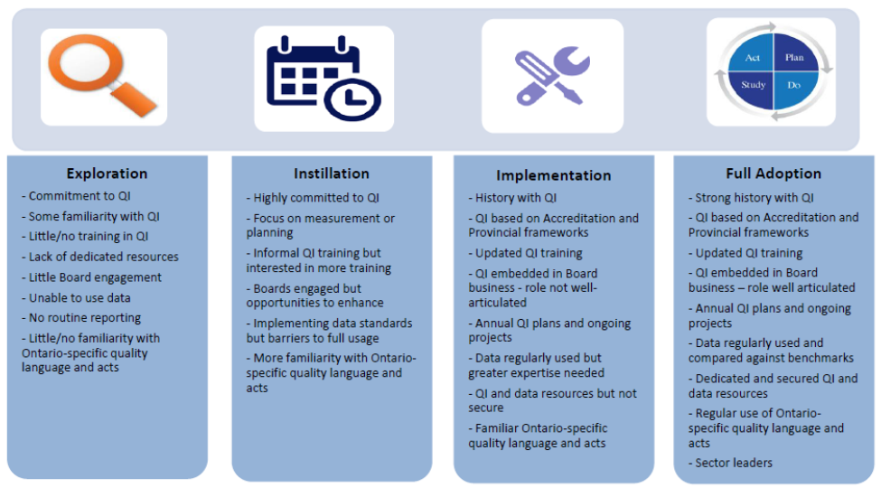
* BY SIGNING BELOW, I DECLARE MY SUPPORT AND ENDORSEMENT OF THIS APPLICATION AND FOR OUR AGENCY TO WORK WITH E-QIP OVER THE NEXT YEAR.

ED/ CEO SIGNATURE: _________________________________
I will attend the day long Executive Sponsor training November 6, 2019.
FOR ADDITIONAL INFORMATION PLEASE CONTACT:
Debbie Bang
Director of Quality Improvement
Addictions & Mental Health Ontario
Debbie.bang@amho.ca
416.490.8900 ext. 1623

